PLANT UNIT READING GUIDE Mrs. Javon
Chapter 26 Active Reading Guide The Colonization of Land by Plants

Section 1
- Plants colonized land about 500 million years ago. Which group of algae is believed to be the ancestors of land plants?

Section 3 (SKIP Section 2)
- Like the Bryophyta, ferns are most common in damp environments. What feature of their reproduction requires them to live in a moist habitat?

- What are the two types of vascular tissue? What does each transport?

- Ferns are vascular plants. Why can vascular plants grow to be very tall, but nonvascular plants are all tiny?

- Lignified vascular tissue allows vascular tissues to grow very tall. How does this give vascular plants a competitive edge?

- What are functions of roots?

- What is the function of leaves?

Section 4
- List five characteristics common to all seed plants.

1.

2.

3.

4.

5.

- In seed plants, the evolutionary trend of gametophyte reduction continues. List four advantages the plant gains by the miniaturization of the gametophyte.

1.

2.

3.

4.

- What is the purpose of pollination?

- What are two advantages of pollen over free-swimming sperm?

- What are three advantages of seeds over spores?

- Concerning seeds, what is the difference between gymnosperms and angiosperms?

- What is the specialized function of the flower?

- Briefly give the function of each flower part.

Sepal:

Petal:

Stamen:

Anther:

Filament:

Carpel:

Stigma:

Style:

Ovary:

Ovule:
Label all parts of the flower. Then, circle the flower parts that are essential for reproduction.
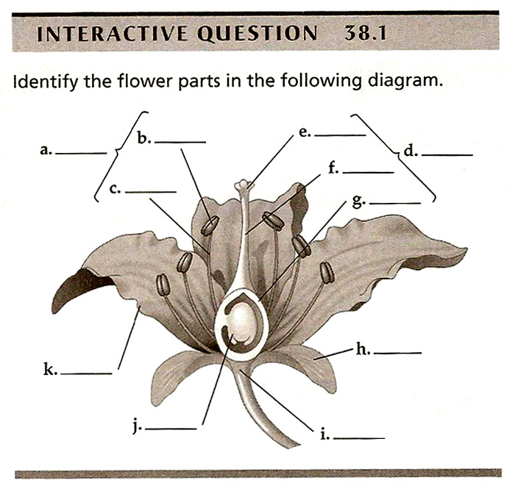

- A fruit consists of a mature .

- List the two functions of fruits.

- What is the difference between cross-pollination and self-pollination? What is the evolutionary advantage of cross-pollination?

Chapter 28 Active Reading Guide: Plant Structure and Growth

Section 1
- This concept is organized into three sections—plant organs, tissues, and cells. Begin by defining a tissue and an organ.

- The three plant organs are __________, __________, and __________.

- Define root and then explain the difference between a taproot and lateral roots.
root:

taproot and lateral roots:

- Figure 28.4 in your text shows the root hairs of a radish. What is the function of root hairs?

- What is the general function of stems?

- The main function of a leaf is ____________________.

- In addition, leaves ________________________________________, _________________, and ____________________________________________.

- What are four additional functions that modified leaves can perform?

  - _________________________ 3. _________________________

  - _________________________ 4. _________________________

- Plants have three types of tissues. What are their functions?

Tissue Type | Function
Dermal Tissue System

Vascular Tissue System

Ground Tissue System

- What is the function of the cuticle?

- Xylem conducts ___________________. Phloem conducts _____________________.

Section 2
- What is the difference between indeterminate growth and determinate growth?

- Although plants generally show indeterminate growth, what are three examples of plant parts that show determinate growth?

- Plants are capable of indeterminate growth because they have perpetually embryonic tissues called ____________________.

- Differentiate between primary growth and secondary growth.

Section 3
- Explain what events occur in the zone of cell division, zone of elongation, and zone of differentiation in roots.

- On the diagram of the leaf cross-section, label the cuticle, stoma, guard cells, upper epidermis, lower epidermis, palisade layer, parenchyma cell, spongy layer, air space and vein. Also label each structure with the function it serves.
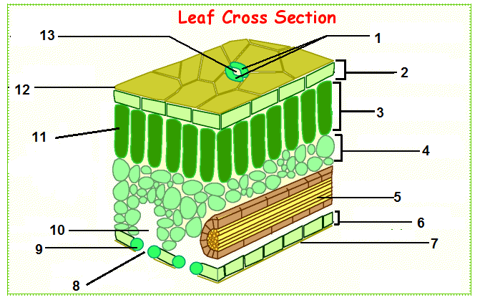

22. What is in the vein of the leaf?

23. Where does most photosynthesis occur in the leaf?

Section 4

24. What vascular tissue forms the bark, and what is the function of the bark?

- What tissues are included in the bark of a tree?

- Look back at the stem in Figure 28.19 and find the horizontal slits in the bark, known as lenticels. You may have noticed lenticels on the young twigs of trees or shrubs. What is the function of lenticels?

Chapter 29 Active Reading Guide: Resource Acquisition, Nutrition, and Transport in Vascular Plants

Section 1
- Competition for light, water, and nutrients is intense among the land plants. Let’s look first at adaptations to increase light capture. Why do most angiosperms have alternate phyllotaxy?

- What triggers self-pruning?

- What are mycorrhizae, and what is their role in resource acquisition?

Section 2
The information in the next group of questions should be familiar to you. Also, many AP courses do AP Laboratory 4, Diffusion and Osmosis, along with Chapter 5. This lab covers the concept of water potential, so now might be a good time to review that lab activity.

- Transport in plants involves the same mechanisms seen in other cells, but for now, let’s focus on some ways plants differ from animals in solute transport. As you read your text, study Figure 29.5 to highlight processes of solute transport across plant cell membranes. Give a short description of each process.

- Plant cells have a rigid cell wall, which adds another factor that affects osmosis:
pressure. Define water potential.

- By definition, what is the Ψ_{s} of pure water? __________

- How does adding solute to pure water affect water potential?

- The solute potential of a solution is therefore always ____________.

- What is pressure potential? Under what conditions will it decrease?

- To summarize, water moves from regions of ____________ water potential to regions of ____________ water potential.

- Define these terms:
flaccid:

turgid:

plasmolysis:

- In Figure 29.6, a plant cell that has an initial water potential of –0.7 MPa is placed into two different conditions. Explain, in terms of water potential, what is happening in each case.
(a)

(b)

- What are aquaporins?

- If a plant cell immersed in distilled water has a Ψ_{s} of -0.7 MPa and a Ψ of 0 MPa, what is the cell’s Ψ_{p}? If you put it in an open beaker of solution that has a Ψ of -0.4 MPa, what would be its Ψ_{s} at equilibrium?

Section 3
- What is an essential nutrient? (Text refers to essential elements.)

- What are the nine macronutrients? List them in order of relative abundance in plants. (You may use atomic symbols.)

- What is a primary role of magnesium?

- What three macronutrients are most commonly deficient? (Figure 29.8) You should notice that these are the same three nutrients found in most fertilizers.

- Which nutrient is most limiting to plant growth on a global scale?

Section 4
- Plants have mutualistic relationships with bacteria that help make nitrogen more available. Nitrogen-fixing bacteria such as Rhizobium are able to convert atmospheric nitrogen (N₂), which plants cannot use, to ammonia (NH₃), which they can use. Briefly describe the nitrogen cycle.

- Where is the nitrogen-fixing bacterium Rhizobium found?

- The principle of crop rotation employs alternation of a crop that depletes nitrogen with a legume crop that fixes nitrogen. In the United States, this often means alternation of corn with soybeans. Which of these two crops is the nitrogen depleter? The nitrogen fixer?

- How do mycorrhizae enhance plant nutrition?

- In many parts of the eastern United States, garlic mustard has become a serious pest. What is its negative impact on native species, and how does it appear to do this?

- What is an epiphyte? Name three different plant types that are epiphytic.

- Dodder and Indian pipes are nongreen, nonphotosynthetic flowering plants. How do they obtain nutrients?

- Carnivorous plants such as the Venus flytrap and sundews are photosynthetic. Why, then, do they capture insects?

Section 5
- What is the role of the Casparian strip?

- What is transpiration?

- What is the cohesion-tension hypothesis? Explain this hypothesis.

Section 6
- Leaves generally have large surface areas and high surface-to-volume ratios. Give an advantage and disadvantage of these traits.
advantage:

disadvantage:

- Plants lose 95% of their water through stomata! What controls the amount of water loss?

- Explain why the stoma opens when K⁺ accumulates in the guard cells.

- Three types of stimuli can cause guard cells to open stomata. Name and explain how each one works.

- What plant hormone is produced in response to water deficiency?

- List four different physiological or morphological adaptations of xerophytes, and explain how each of them reduces water loss.

Section 7
- What is translocation?

- What is a sugar source, and what is a sugar sink? Give an example of each.

- What cell types transport the sugars?

Chapter 30 Active Reading Guide: Reproduction and Domestication of Flowering Plants

Section 1
- Meiosis in the male gametophyte produces four microspores. How many survive? ____
- Meiosis in the female part of the plant produces four megaspores. How many survive? _____

- What occurs in pollination?

- Describe what happens in double fertilization.

- After double fertilization, what does each ovule become?

- After double fertilization, what does each ovary become?

- Study Figure 30.6 in your text. List four modes of pollination. For each mode, describe a feature of the flower that aids pollination.
1)

2)

3)

4)

- What is the function of a seed coat?

- What part of the embryo plant emerges first?

- What are some mechanisms that maintain seed dormancy?

- What is imbibition?
- To a botanist, a fruit is a ripe __________. It does not have to be sweet! A pea pod is a fruit. A green pepper is a fruit.

- An important function of the fruit is to aid in dispersal. Study Figure 30.12 in your text. What are three primary methods of each?
1)

2)

3)

Section 2
- Asexual reproduction in plants is also known as vegetative propagation. Describe two different types of asexual reproduction in plants.

- Why is it important for plants to have mechanisms to prevent self-fertilization?

- What are three mechanisms to prevent self-fertilization?

Section 3
- Humans have used selective breeding to develop useful varieties since the dawn of agriculture. Today, biotechnology has accelerated the introduction of desirable traits. List three genetically modified plant species, and describe the advantage each species shows.
a.

b.

c.

- Genetically modified organisms (GMOs) offer great promise but are also controversial. What are three of the possible risks?
a.

b.

c.

Chapter 31 Active Reading Guide:
Plant Responses to Internal and External Signals

This concept brings together the general ideas on cell communication from Chapter 5.6 with specific examples of signal transduction in plants. As with animals, plants have receptors that trigger signal transduction pathways when activated. Let’s begin with a review of three steps in signal transduction.
Step 1: Reception
Cell signals are detected by receptors that undergo changes in shape in response to a specific stimulus.
Step 2: Transduction
Transduction is a multistep pathway that amplifies the signal. This effect allows a small number of signal molecules to produce a large cellular response.
Step 3: Response
Cellular response is primarily accomplished by two mechanisms: a. increasing or decreasing mRNA production
b. activating existing enzyme molecules

Section 1
- Define hormone.

- Plant physiologists think the term hormone as defined above doesn’t quite fit plants. What term do they use instead?

- What is a tropism?

- What can be concluded from the phototropism experiments conducted by Charles and Francis Darwin?

- What conclusions can be drawn from the Boysen-Jensen experiment?

- What name did Went give to the chemical messenger involved in phototropism?

- In jest, students are often told that when in doubt about which plant hormone causes which plant response, just answer auxin. Auxin has so many functions, this answer often works. List and describe four functions of auxin.
1.

2.

3.

4.

- List and describe three functions of cytokinins.
1.

2.

3.

- Gibberellins occur naturally in plants, and like the previous two hormones, they have several effects. Describe three of them.
1.

2.
3.

- Abscisic acid (ABA) is misnamed. Why?

- Describe two effects of abscisic acid.
1.

2.

- Ethylene is the only hormone in our group that is a gas. Under what conditions is ethylene produced?

- The effects of ethylene are many and varied. Describe them here.
1.

2.

3.

4.

- You have just finished a very complex look at plant hormones. Let’s try to summarize it by completing the following chart.
Hormone | Action
 | leaf abscission
 | breaking seed dormancy
 | maintaining apical dominance
 | making internodes of grape bunches elongate to obtain larger fruit
 | gravitropism
 | drought tolerance
 | senescence
 | phototropism
 | cell elongation
 | increased cell division

Section 2
- Researchers have determined that plants have two major classes of light receptors. List each class.

- What wavelengths of light are absorbed by phytochromes?

- What is a circadian rhythm? Give one plant example and one human example.

- What is the photoperiod?

- Plants detect photoperiod, and in many species, it affects their time of flowering. Explain each of the following, and give an example of a plant that is in the group. short-day plant:

long-day plant:

day-neutral plant:

- What is florigen?

Section 3
- What is gravitropism? How may a plant detect gravity?

- What is thigmotropism? How is it adaptive?

- Describe an example of a rapid leaf movement. What do these action potentials resemble?

- List four different ways in which a plant responds to water deficit.
1.

2.

3.

4.

- Select any other stress situation besides water deficit, and explain plant mechanisms for dealing with this.

Section 4
- What are the two ways in which plants combat excess herbivory?

- Describe two examples of a plant producing chemicals to deal with herbivory.

