Chapter 20 Active Reading Guide: Phylogeny Mrs. Javon

Overview
- What is systematics? How is it used to develop phylogenetic trees?

Section 1
- What is taxonomy?

- Every organism on Earth may be referred to by a unique binomial, or a two-part name. These are in Latin, or latinized. What is your binomial? What does it mean?

- What are the two components of every binomial?

- Taxonomy uses hierarchical categories that nest within each other, like Russian dolls. Figure 20.3 shows the categories, each called a taxon. Which levels of classification in the figure do humans share with leopards?

- So, which are more closely related, organisms in the same phylum, or those in the same order?

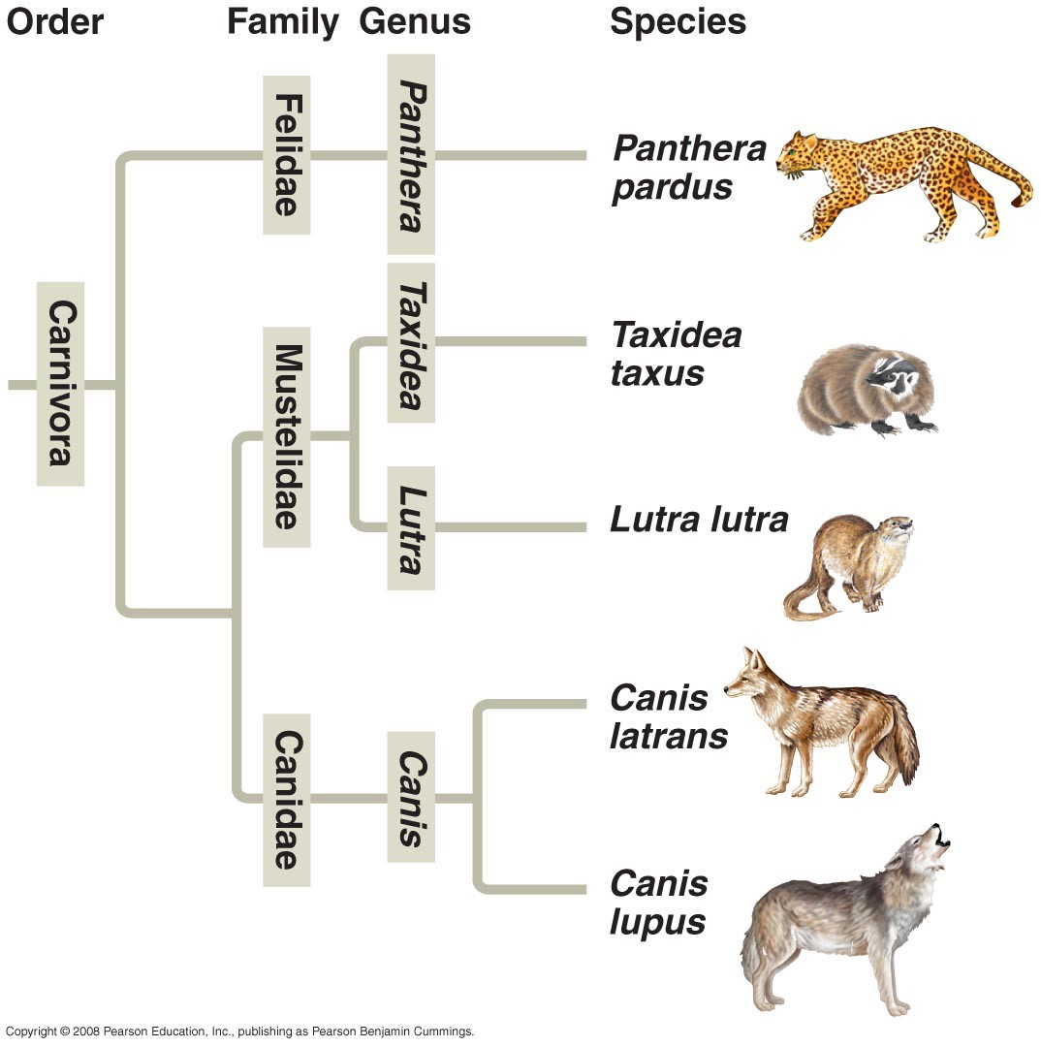
- Here is a phylogenetic tree. Recall that branch points represent common ancestors of the two lineages beyond the branch or node. Circle the common ancestor of badgers and otters, and label it as A. Circle the common ancestor of cats and dogs, and label it as B.

Section 2
Look back at the Study Tip from Chapter 19. This idea is repeated in the current chapter.
- Molecular systematics is a valuable tool used today to sort homology from analogy. What is molecular systematics?

Section 3
- Figure 20.10 shows three cladograms. What is a clade?

- Why is Group I monophyletic?

- Explain why Group II is paraphyletic.

- What is a polyphyletic group?

- Clades are derived by using shared derived characters. What are these?

- Explain why for mammals, hair is a shared derived character, but a backbone is a shared ancestral character.

Section 4
- What are molecular clocks?

- If we use a molecular clock, approximately when did HIV emerge?

Section 5

- What two domains include all prokaryotes?

- Which two domains are most closely related? Explain your reasoning.

- Which kingdom is made obsolete by the three-domain system? Why?

- Which kingdom crumbled because it is polyphyletic?

- Explain the role of horizontal gene transfer in the ring of life hypothesis.

