Chapter 17 Active Reading Guide: Viruses Mrs. Javon

Section 1
- Are viruses living or nonliving? Explain.

- What are the four forms of viral genomes?
1)

2)

3)

4)

- What is a capsid? What are capsomeres?

- What is the role of an envelope in animal viruses?

- For the virus shown in the following figure, label the protein capsid, tail fibers, head, tail sheath, and genome.
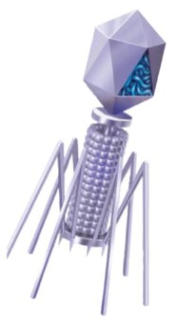
  - What type of virus is this? __________________

  - What does its name mean? __________________

  - What is its host? __________________

  - Is the genome of this virus DNA or RNA? ________

Section 2
- Viruses are obligate intracellular parasites. What does this mean?

- What is meant by host range? Distinguish between a virus with a broad host range and one with an extremely limited host range, and give an example of each.

- Compare the host range for West Nile virus to that of the human cold virus.

- What components of the host cell does a virus use to reproduce itself?

- How does a DNA virus reproduce its genome?

- How do most RNA viruses replicate their genome?

- Explain the 4-step process of viral reproduction.
1)

2)

3)

4)

- What are bacteriophages? Distinguish between virulent and temperate phages.

- What portion of a phage enters the host cell? How does it do this?

- What are restriction enzymes? How do they help prevent viral infection of bacteria?

- Why don’t restriction enzymes destroy the DNA of the bacterial cells that produce them?

- What is a prophage?

- Since cells that have incorporated phage DNA into their genome may continue to divide and propagate the viral genome, this might be considered somewhat like the Trojan horse. What might trigger the switchover from lysogenic to lytic mode?

- Describe the lytic and lysogenic modes of bacteriophage reproduction.

- There are some general differences between bacteriophages and animal viruses. What are two elements that nearly all animal viruses have?

- What is a retrovirus? How do retroviruses, such as HIV, replicate their genome?

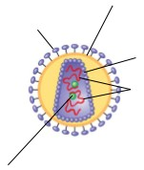

- Here is a sketch of HIV. Label these parts:
envelope, glycoprotein, reverse transcriptase, RNA, and capsid.

- Compare and contrast a prophage and a provirus. Which one are you likely to carry?

- Explain the infection of a cell by HIV.

- The final section in Concept 17.2 is titled “Evolution of Viruses.” From this part, describe the two possible sources of viral genomes. You will see each of these important mobile genetic elements again.
Description of the Mobile Genetic Element
Plasmids

Transposons

Section 3
- What causes the symptoms of viruses such as fever and body aches?

- Why are vaccines not cures for diseases?

- You go to the doctor with a fever, sinus congestion and cough. The doctor diagnoses you with a cold. The doctor gives you a prescription for penicillin. What is wrong with this scenario?

- Emerging viruses such as HIV, Ebola, and SARS seem to burst upon the human scene. What are three processes that contribute to this sudden emergence?
1)

2)

3)

- The 2009 flu pandemic is H1N1. What is a pandemic? What does the name of the flu mean?

- What are two major routes viral diseases are spread in plants.

