Chapter 13 Active Reading Guide: The Molecular Basis of Inheritance

Section 1
- What are the two chemical components of chromosomes?

- Why did researchers originally think that protein was the genetic material?

- Distinguish between the virulent and nonvirulent strains of Streptococcus pneumoniae studied by Frederick Griffith.

- What was the purpose of Griffith’s studies?

- Summarize the experiment in which Griffith became aware that hereditary information could be transmitted between two organisms in an unusual manner.

- Define transformation.

- What did Oswald Avery determine to be the transforming factor?

- Sketch a T2 bacteriophage and label its head, tail sheath, tail fiber, and DNA.

- How does a bacteriophage destroy a bacterial cell? Look ahead to Chapter 17, Figure 17.4, to explain this.

- How did Hershey and Chase “label” viral DNA and viral protein so that they could be distinguished? Explain why they chose each radioactive tag in light of the chemical composition of DNA and protein.

- Describe the means by which Hershey and Chase established that only the DNA of a phage enters an E. coli cell. What conclusions did these scientists draw based on these observations?

- What are Chargaff’s rules? How did he arrive at them?

- List the three components of a nucleotide.

- Who are the two men who built the first molecular model of DNA and shared the 1962 Nobel Prize for discovery of its structure?

- What was the role of Rosalind Franklin in the discovery of the double helix?

- Distinguish between the structure of pyrimidines and purines. Explain why adenine bonds only to thymine.

- How did Watson and Crick’s model explain the basis for Chargaff’s rules?

- Given that the DNA of a certain fly species consists of 27.3% adenine and 22.5% guanine, use Chargaff’s rules to deduce the percentages of thymine and cytosine.

- Name the five nitrogenous bases, and put a checkmark in the correct column for each base. Also indicate if the base is found in DNA, RNA, or both.

Nitrogenous Base | Purine | Pyrimidine | DNA, RNA, or Both

- What DNA base is complementary to adenine?

What DNA base is complementary to guanine?
- Describe the structure of DNA relative to each of the following:

  - distance across molecule

  - distance between nucleotides

  - distance between turns

  - components of the backbone

  - components of the “rungs”

- Explain what is meant by 5' and 3' ends of the nucleotide.

- What do we mean when we say the two strands of DNA are antiparallel?

Section 2
- What is the semiconservative model of replication?

- Use Figure 13.11 to explain how Meselson and Stahl confirmed the semiconservative mechanism of DNA replication.
- Define the origins of replication.

- Distinguish between the leading and the lagging strands during DNA replication.

- What is the direction of synthesis of the new strand?

- What are Okazaki fragments? How are they welded together?

- Which enzyme does each of the following?

  - untwists and separates strands

  - holds DNA strands apart

  - synthesizes RNA primer

  - adds DNA nucleotides to new strands

  - relieves strain caused by unwinding

  - joins DNA fragments together

  - removes RNA primer and replaces with DNA

- Make a detailed list of the steps that occur in the synthesis of a new strand.

- What is a thymine dimer? How might it occur? How is it repaired?

- Make a sketch of a chromosome and label the telomeres.

- Explain telomere erosion and the role of telomerase.

- Why are cancer cells immortal even though most body cells have a limited life span?

- Explain the roles of each of the following enzymes in DNA proofreading and repair.

  - DNA polymerase

  - Nuclease

  - Ligase

  - Repair enzymes

Section 3
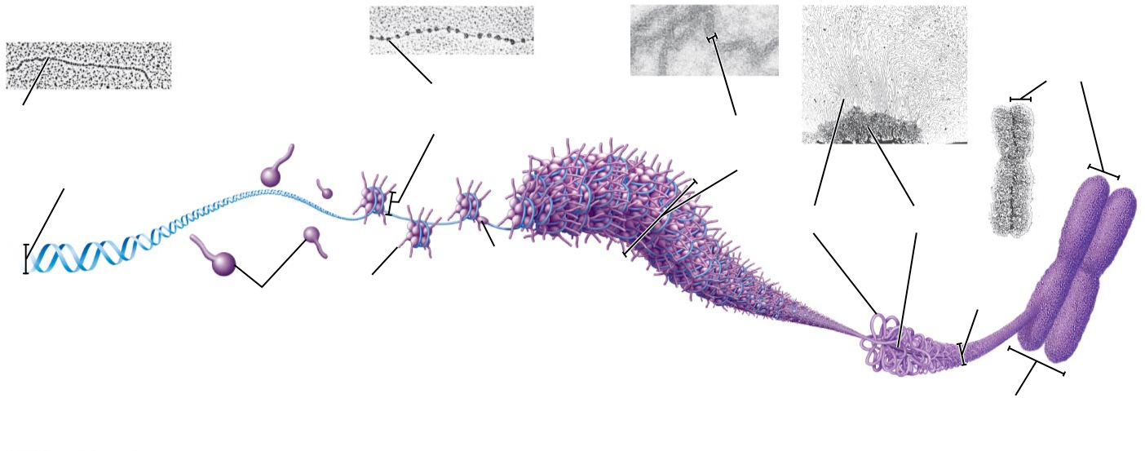
- On the following diagram, identify the following: 30-nm fiber, metaphase chromosome, double helix, histone proteins, nucleosomes, protein scaffold, and looped domains (300-nm fiber).
- Distinguish between heterochromatin and euchromatin.

Section 4

- Define the following
  - Recombinant DNA
  - Genetic engineering
  - Biotechnology
  - Gene cloning
- Why did restriction enzymes evolve in bacteria?

- Define the following terms

  - Restriction site
  - Restriction fragments
  - Sticky end

- Using the diagram below – label the steps to cloning a human gene in a bacterial plasmid
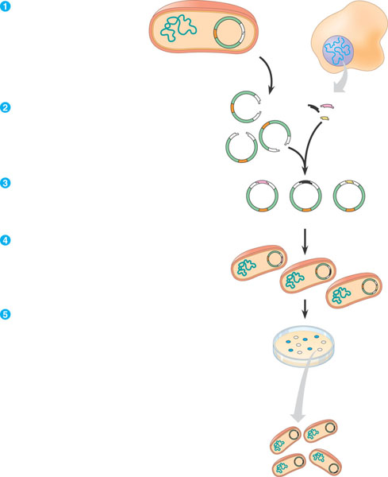
- Why is PCR – polymerase chain reaction important in many aspects of biotechnology?
- Label the diagram of PCR below.
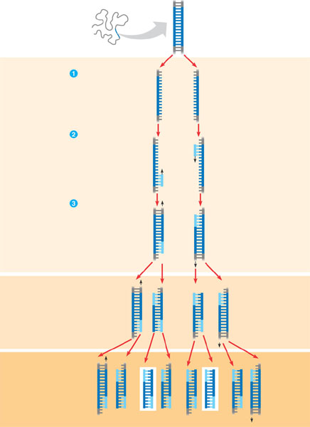
- What is the purpose and general process of gel electrophoresis?
- Label the diagram below – focus on the charge, molecule size and results.
