Cell Communication Web Quest
Name

View the cell communication animation at the following URL and use this to answer the following questions.

http://www.phschool.com/science/biology_place/biocoach/biomembrane2/surface.html
- What is a receptor?
- What is signal transduction?

View the cell communication animation at the following URL and use this to answer the following questions.

http://media.pearsoncmg.com/bc/bc_campbell_biology_7/media/interactivemedia/activities/ load.html?11&A
- What are the three stages in the cell signaling process?

- What is a ligand?

- Why does the ligand have to fit with the receptor molecule?

- Why does signal transduction often involve a change in the shape of the receptor?

- List three cellular responses that signal transduction can produce.

View the cell communication animation at the following URL and use this to answer the following questions.

http://media.pearsoncmg.com/bc/bc_campbell_biology_7/media/interactivemedia/activities/ load.html?11&B
- How do most signal molecules act on target cells?

- List four different kinds of receptors in target cells.

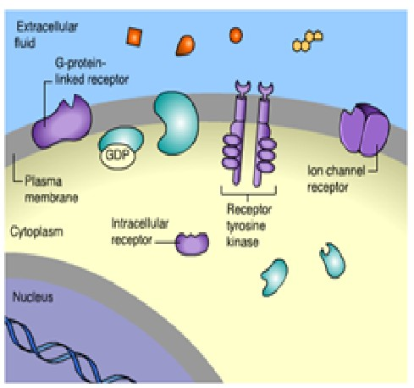

** Click on the G-protein linked receptor in the animation. Then click on the correct signal molecule to activate the G-protein-linked receptor shown.

- Discuss at least two events involved in causing the change in enzyme activity once the G-protein linked receptor is activated.

** Click on the receptor tyrosine kinase in the animation. Then click on the correct signal molecule to activate the receptor tyrosine kinase shown.

- How does the bonding of the signal molecule to the receptor tyrosine kinase lead to the activation tyrosine-kinase enzymes?

- How does the activated receptor tyrosine kinase trigger several different effects within the cell?

** Click on the ion channel receptor in the animation. Then click on the correct signal molecule to activate the ion channel receptor shown.

- What are ligand gated ion channels?

- Explain how signal proteins can activate ion channel proteins.

** Click on the intracellular receptor then click on the correct signal molecule to activate the intracellular receptor shown.

- Where are intracellular receptors located?

- List two examples of steroid hormones that act on intracellular receptors.

- Explain why nonpolar molecules are able to pass through the plasma membrane to bind to intracellular receptors. (thought question)

- Explain how steroids cause changes inside a cell.
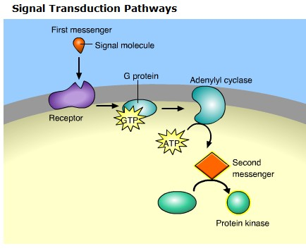
View the cell communication animation at the following URL and use this to answer the following questions.

http://media.pearsoncmg.com/bc/bc_campbell_biology_7/media/interactivemedia/activities/ load.html?11&C
- What are signal transduction pathways?

- List two things signal transduction pathways allow for.
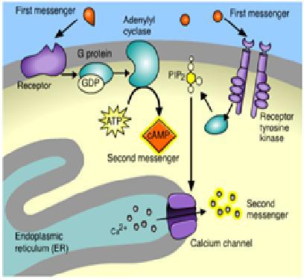
- What are second messengers?

- List 2 important second messenger molecules.
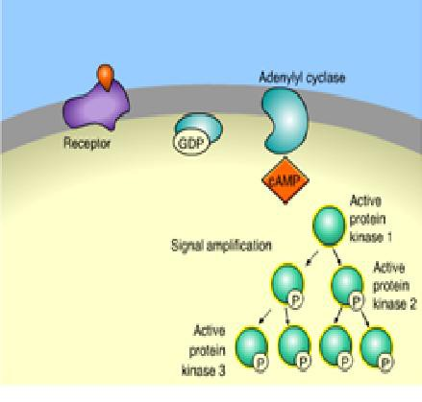

- What is a protein kinase?

- Discuss how protein kinases function to produce signal amplification in a cell.

Cell Communications Multiple Choice Quiz

- Which molecule is most likely to serve as a signal molecule? (1.) ligand (2.) protein (3.) initiator (4.) key (5.) receptor

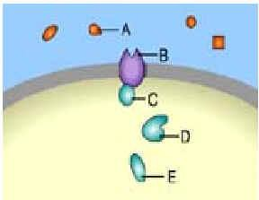
Use the diagram below from the Campbell website and section 5.6 of your text book to answer

- Which is a receptor molecule? (1.) A (2.) B (3.) C (4.) D (5.) E

- Which is a signal molecule? (1.) A (2.) B (3.) C (4.) D (5.) E

4. Which of these molecules could diffuse through a plasma membrane and bind to an intracellular receptor?
(1.) estrogen (2.) glycerol (3.) cellulose (4.) glucose (5.) starch

- Which molecule catalyzes the formation of second messenger molecules?
- carrier protein (2.) gap junction (3.) cAMP (4.) adenylate cyclase (5.) G-protein

- Which is most associated with paracrine signaling?
(1.) insulin stimulating glucose intake into cells
(2.) growth factors stimulating neighboring cells
(3.) epinephrine in the blood stream
(4.) pheromones communicating between members of a species

- What are the carbohydrates on the surface of the plasma membrane used primarily for? (1.) none of these (2.) give energy to other cells (3.) communication between cells (4.) energy storage

- Which serves as an intracellular second-messenger molecule?
(1.) carrier protein (2.) gap junction (3.) cAMP (4.) adenylate cyclase (5.) G-protein

- Second messengers tend to be both water-soluble and small. This accounts for their ability to
(1.) rapidly cross the plasma membrane
(2.) rapidly move throughout the cell by diffusion
(3.) pass quickly from cell to cell
(4.) move from substrate to substrate during a phosphorylation cascade
(5.) cross the nuclear membrane and interact with DNA

- Which would be most directly involved with the enhancement of lipophilic signals in the blood
(1.) carrier protein (2.) gap junction (3.) cAMP
(4.) adenylate cyclase (5.) G-protein

- A steroid hormone is different from many other types of hormones in that: (1.) the steroid hormone is made of amino acids
(2.) the steroid hormone causes a change to how the cell functions
(3.) the steroid hormone binds to a receptor in the cytoplasm of the target cell (4.) the steroid hormone usually does not enter target cells

- The sequence of events involved in cell signaling is (1.) transduction → reception → response
(2.) response → reception → transduction (3.) reception → response → transduction (4.) reception → transduction → response

