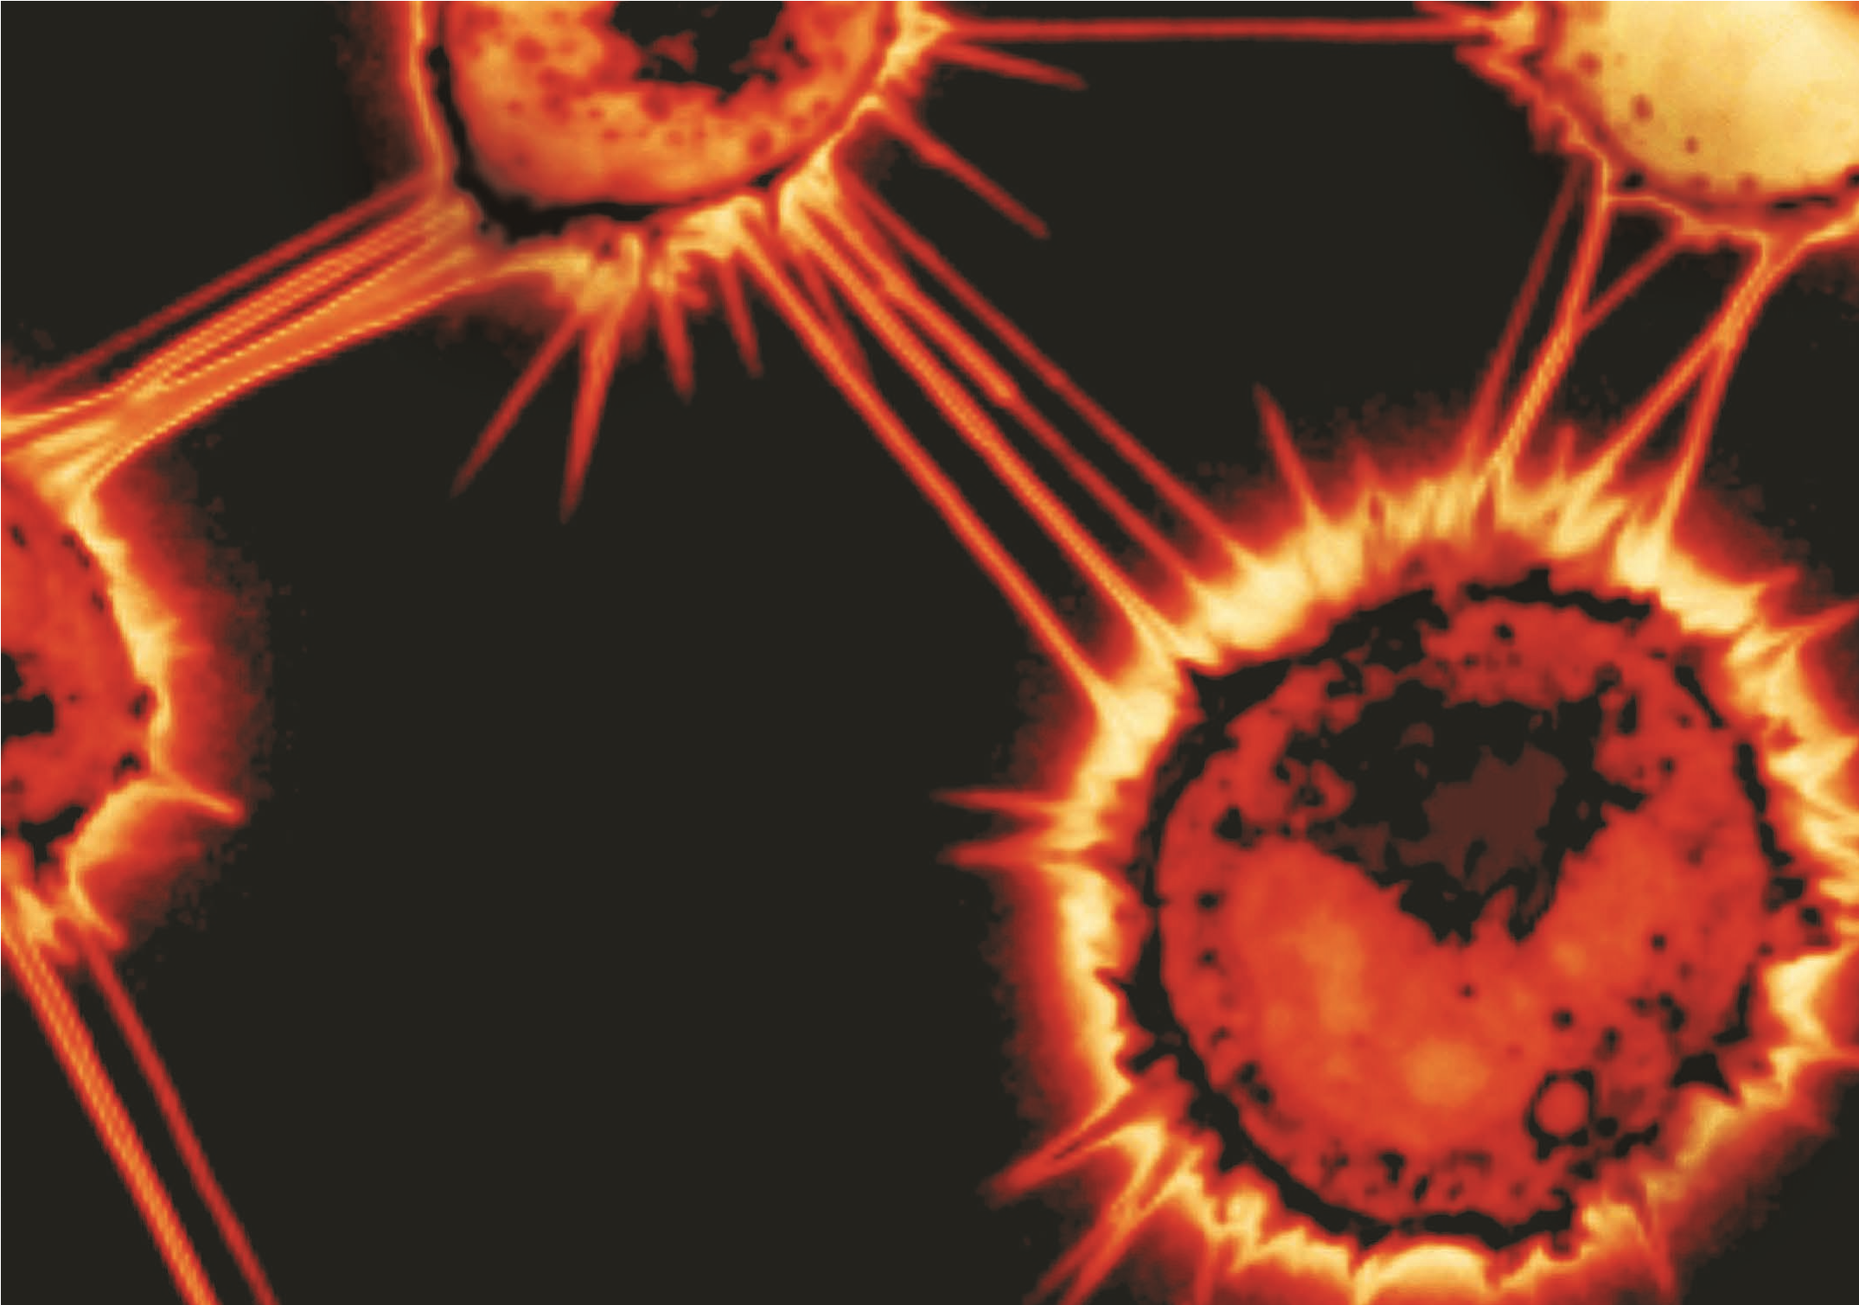
LINES OF COMMUNICATION
KARINE GOUSSET/CHIARA ZURZOLO/PASTEUR INSTITUTE
A previously unappreciated form of cell-to-cell communication may help to spread cancers and infections.
NEWS | FEATURE

B Y M O N YA B A K E R

Y
ukiko Yamashita thought she knew the fruit-fly testis inside out. But when she carried out a set of experiments on the organ five years ago, it ended up leaving her flummoxed.
Her group had been studying how fruit flies maintain their sperm supply and had engineered certain cells in the process to produce specific sets of proteins. But instead of showing up in the engineered cells, some proteins seemed to have teleported to a different group of cells entirely. Yamashita, a developmental biologist at the University of Michigan in Ann Arbor, and the postdoctoral researcher with whom she was working, Mayu Inaba, called the phenomenon “mysterious trafficking”. They were convinced it was real — but they couldn’t understand how it worked. So they shelved the project until one day, more than a year later, .Inaba presented Yamashita with some images of tiny tubes reaching out from one cell to another — delicate structures that might have been responsible for the trafficking. Yamashita was skeptical, but decided to dig out images from her own postdoc project 12 years earlier. Sure enough, slender spikes jutted out towards the targeted cells. “It was really eye-opening,” Yamashita says. The group published its work in 2015, arguing that the tubes help testis cells to communicate precisely, sending a message to some of their neighbors and not others¹. “We thought the protein was trafficked,” Yamashita says, “but we didn’t think there was an actual track.”
Yamashita’s tubes joined a growing catalogue of cryptic conduits between cells. Longer tubes, reported in mammalian cells, seem to transport not just molecular signals but much larger cargo, such as viral particles, prions or even mitochondria, the cell’s energy-generating structures. These observations suggest an unanticipated level of connectivity between cells, says Amin Rustom, a neurobiologist at the University of Heidelberg in Germany, who first spotted such tubes as a graduate student almost 20 years ago. If correct, he says, “it would change everything in medical applications and biology, because it would change how we see tissues”.
But Richard Cheney, a cell biologist at the University of North Carolina in Chapel Hill, is not ready to start revising the textbooks. Cheney has followed the field and at one point collaborated with Rustom’s PhD adviser. There’s no question that long, thin protrusions are popping up all over the place, he says. The question is, what are they doing — sending simple messages when cells reach out and touch each other, or opening a breach and facilitating wholesale transport? “I’d probably bet on contact-based signaling, where you don’t need very many copies of a molecule, as opposed to them acting like interstate highways,” he says.
The problem with betting either way is that these tiny tubes are tough to study. Arguing that they exist at all is hard enough, let alone making the case that they actually have a function. Yamashita used the tried-and-tested genetic- engineering methods and well-characterized genes available in the fruit fly to argue that her tubes were sending signals by direct contact. But researchers looking for tubes in mammalian cells don’t have those resources. More than one researcher has been accused of mistaking a scratch on a cell plate for a cell-produced nanotube. Evidence derived from real mammalian tissue is even sparser.
Nonetheless, there has been a recent rash of interest in the tubes. One of the believers is George Okafo, a director of emerging platforms at the drug company GlaxoSmithKline (GSK) in Stevenage, UK. He thinks that cell to-cell protrusions could explain why diseases such as Alzheimer’s disease, Parkinson’s disease and malaria, as well as HIV and prion infections, are so difficult to treat (see ‘Live wires’). “There’s a characteristic that isn’t targeted by a lot of conventional therapies, and that’s how a disease spreads from cell to cell.” Last September, Okafo organized an invitation-only conference to bring together GSK staff and around 40 researchers in the field. (He is now collaborating with some of them.) In March this year, the US National Institutes of Health asked for grant applications from groups studying how organelles communicate in stressed or cancerous cells, a move that excites tube enthusiasts. And in December, the American Society for Cell Biology will host a session devoted to the topic at its annual meeting.

LONG PIPELINE
Scientists know that some cells build wire-like extensions as a kind of temporary foothold to move themselves from place to place. The first important hint that they might be involved in something more complex came in 1999, from cell biologist Thomas Kornberg at the University of California, San Francisco. He was watching fly larvae develop wings, and saw a
“IT WOULD
FEATURE | NEWS
CHANGE HOW WE SEE TISSUES.”
sea of filaments projecting from the wing buds towards the signaling center that is essential for their growth². He coined the term cytoneme — or cell thread — to describe these filaments. He suggested that some cellular chatter that was thought to happen by diffusion could, in fact, be orchestrated by cytonemes. The idea was surprising and was slow to catch on, but it is now making its way into textbooks.
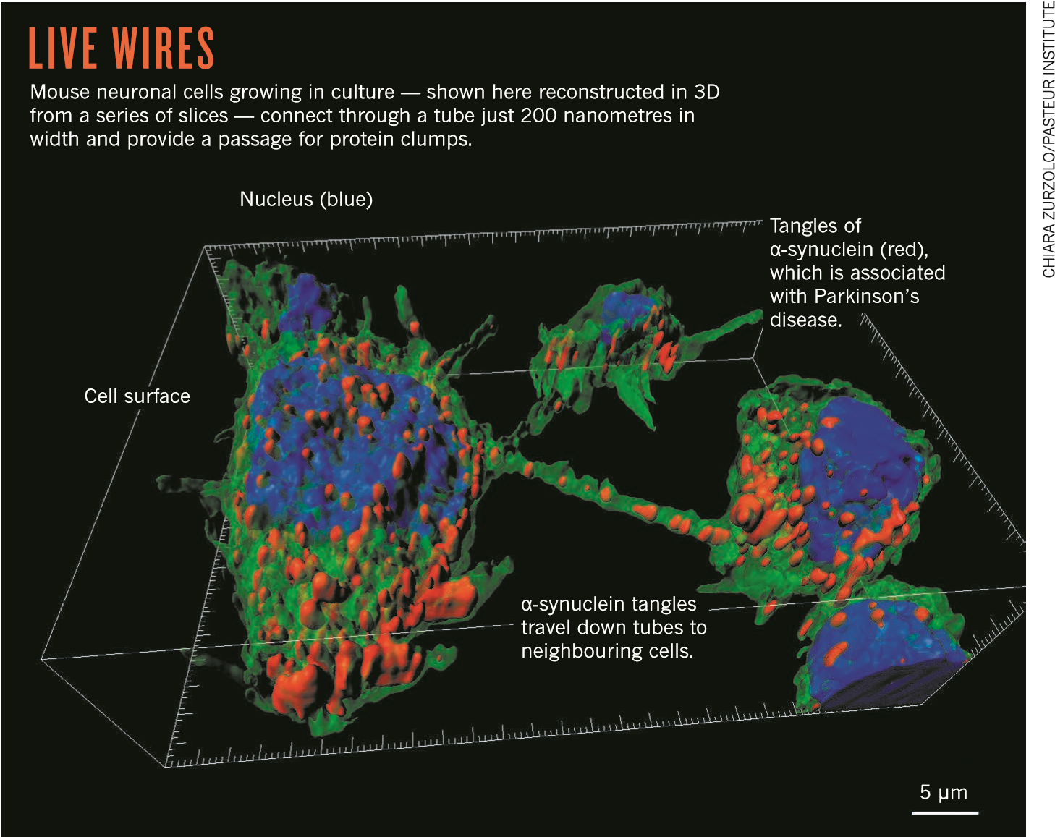
In 2004, two research groups separately published observations of something even more radical: nanotubes in mammalian cells that seemed to move cargo such as organelles and vesicles back and forth. Rustom spotted thin, straight tubes connecting cultured rat cells after he forgot a washing step in an experiment. He and his adviser at the University of Heidelberg, Hans-Hermann Gerdes, engineered cells to make fluorescent proteins and watched the molecules flow from one cell to another. Their accidental sighting grew into a Science paper³ that described the structures as “nanotubular highways”. (Some sceptics think that Gerdes chose the term nanotube to ride on the coat-tails of carbon nanotubes, a hot topic in materials science.)
In the same year, Daniel Davis and his team at Imperial College London described networks of ‘membrane nanotubes’, strands of cells’ outer membranes that stretched for several cell lengths to connect different types of immune cell; lipids produced by one cell showed up on the surface of another⁴. Davis attributes their discovery to his team’s willingness to think through the implications of their sighting. “The crucial thing is not that we saw them,” he says. “The crucial thing is deciding what you’re going to dig into and investigate.” His team went on to describe different sorts of nanotube, some holding vesicles and mitochondria inside, and others with bacteria ‘surfing’ the casing⁵.
Meanwhile, other labs have reported cell connecting tubes in neurons, epithelial cells, mesenchymal stem cells, several sorts of immune cell and multiple cancers. Further types of tube have been spotted as well. In 2010, Gerdes and his team reported that some tubes end in gap junctions: gateways that bestow the neuron-like ability to send electrical signals and can also pass along peptides and RNA molecules⁶. Yamashita speculates that such connections may be more than conceptually related to neuronal synapses. “Membrane protrusions might have evolved first, and higher organisms could have started upgrading them to make neurons for more complicated functions,” she says.
Most researchers who study these cellular pipelines care less about their evolutionary origin than about their role in human health and disease. The strongest evidence for a role in disease came in 2015, also from a team at the University of Heidelberg, led by cancer researcher Frank Winkler. Like others, his team had not set out to study cell protrusions; they wanted to test a system for watching human gliomas grow. Cells derived from the tumors were injected into the brains of mice with windows in their skulls — hardened glass kept in place with dental cement — through which the researchers could watch the cells.
2 1 S E P T E M B E R 2 0 1 7 | V O L 5 4 9 | N A T U R E | 3 2 3
As the tumor cells invaded, they sent tubular protrusions ahead of them. A closer look showed many tubes connecting cells through gap junctions. Interconnected cells managed to survive doses of radiation that killed isolated cells, apparently because gap junctions helped to spread the load of toxic ions to neighbours⁷. When radiation did kill linked tumor cells, nuclei from those cells sometimes travelled down a tube, with the tube then expanding into the cleared space to form a vigorous new cancer cell. These ‘tumor microtubes’ were also found in biopsies from patients, and denser, longer tubes correlated with more resistant forms of cancer and a poorer prognosis. Winkler speculates that a drug that could keep these tubes from sprouting or extending might create a new class of cancer treatment; indeed, he thinks that existing cancer drugs such as paclitaxel may work by disrupting tumor microtubes. Winkler’s team has filed a patent application for a compound that interferes with microtubes as a treatment for glioma. The work has captured imaginations. “It was a seminal paper,” says Okafo. “Prior to that there was still some skepticism about whether these phenomena existed in vivo.” But it’s not clear whether Winkler’s results apply to other scenarios. Various sorts of brain cell are known to send out cell protrusions as they grow and proliferate. The tubes that Winkler’s team reported are much larger than the ‘tunneling nanotubes’ that were originally described by Gerdes, and, unlike most tunneling nanotubes reported so far, contain microtubules — filaments that move components around in cells. However, Winkler thinks that his work provides evidence for a broad role for tunneling-nanotube-like structures. He thinks they may not be able to reach full size in culture, and the tubes he does see vary considerably in length and thickness. Winkler recalls discussing his work with Gerdes before Gerdes’ death in 2013. “He said that this was what the field was waiting for. It was exactly the proof that he thought we could find.”
In other fields, too, the tubes are gaining traction. Eliseo Eugenin, who studies HIV at Rutgers New Jersey Medical School in Newark, suggests that HIV-infected cells send out multiple nanotubes filled with virus to reach uninfected cells. Circulation and one-on-one cellular contact would be too inefficient to cause the rapid amplification of the virus seen in newly infected patients. “The mathematics don’t work,” he says. He thinks that other researchers are skeptical of nanotubes because they are unable to reconcile themselves to the idea that cells are constantly exchanging materi als, including genetic information. “Our definition of a cell is falling apart,” Eugenin says. “That is why people don’t believe in these tubes, because we have to change the definition of a cell.”

BATTLE LINES
When the definition of the cell is at stake, it is little wonder that skepticism remains strong. Emil Lou, a cancer researcher at the University of Minnesota in Minneapolis, says his grant proposal to hunt for and characterize nanotubes in human cancers was pooh-poohed because a reviewer was not convinced that the structures existed.
Others argue that they do exist — but only in the rarefied world of the Petri dish. Michael Dustin, an immunologist at the University of Oxford, UK, says that he has seen cells in dishes form structures that would never occur in the dense tissue of an organism. For example, white blood cells primed to produce antibodies produce a “beautifully symmetric” bull’s-eye pattern in a dish, very different from the chaos and asymmetry they show in the body.
Then there are mechanistic quibbles: some researchers think that the tubes are open at both ends, with cargo flowing in and out. But that would cause cytoplasm to mix and result in the cells fusing, says Jennifer Lippincott-Schwartz, a cell biologist at the Howard Hughes Medical Institute Janelia Research Campus in Ashburn, Virginia. “The people who think there is a connection need to talk to some biophysicists,” she says. Instead, she thinks that membrane tubes may jut out and make minimal contact, just enough to allow recipient cells to reach out and engulf the tube contents.
NEWS | FEATURE
These disagreements could be contributing to a lack of rigor in the field. Chiara Zurzolo, a cell biologist at the Pasteur Institute in Paris, who has spotted prions and other neurodegenerative proteins travelling through nanotubes, says that many papers do not try to assess whether a tube is closed or open-ended, for
“I THINK WE HAVE TO
TAKE IT SERIOUSLY
AS A THERAPEUTIC TARGET.”
example, or even whether the tubes allow the movement of vesicles or similar material. The proliferation of tube types, and the different names for them, make coherent discussion difficult. “We have to be rigorous in what we call these structures. At the moment it is very messy,” she says.
But getting clear images of living cells will always trump semantics, says Ian Smith, a cell biologist at the University of California, Irvine. “What is really needed in the field is direct visualization of this process,” he says. Most microscopy techniques can’t get a clear view of these structures in action, even in cultured cells. Smith is developing methods to visualize membrane nanotubes using lattice light-sheet microscopy, which monitors planes of light to build up 3D images. He hopes that the technique will be able to capture the process of material transfer from one cell to another, from start to finish⁸. Smith admits that he’s taking a career risk: a colleague recently warned him this area was ‘fringey’. But he takes this as a challenge.
Lou is encouraged that the criticism against membrane tubes has morphed. At first people would tell him that the structures were artefacts or optical illusions, he recalls. “Then it graduated to, ‘well, just because they grow in a plate doesn’t mean that it has anything to do with biology’, and then it was, ‘well you are probably misidentifying these or mischaracterizing them’.” He likes that direction. “I think we have to take it seriously as a therapeutic target. I couldn’t have said that five years ago.” ■

Monya Baker writes for Nature from San Francisco, California.
1. Inaba, M., Buszczack, M. & Yamashita, Y. M. Nature 523, 329–332 (2015). 2. Ramírez-Weber, F. A. & Kornberg, T. B. Cell 97, 599–607 (1999).
- Rustom, A., Saffrich, R., Markovic, I., Walther, P. & Gerdes, H.-H. Science 303, 1007–1010 (2004).
- Önfelt, B., Nedvetzki, S., Yanagi, K. & Davis, D. M. J. Immunol. 173, 1511–1513 (2004).
- Önfelt, B. et al. J. Immunol. 177, 8476–8483 (2006).
- Wang, X., Veruki, M. L., Bukoreshtliev, N. V., Hartveit, E.
& Gerdes, H.-H. Proc. Natl Acad. Sci. USA 107, 17194–17199 (2010).
- Osswald, M. et al. Nature 528, 93–98 (2015).
- Planchon, T. A. et al. Nature Methods 8, 417–423 (2011).

3 2 4 | N A T U R E | V O L 5 4 9 | 2 1 S E P T E M B E R 2 0 1 7

