AP BIOLOGY REVIEW – DAY 7
ECOLOGY
- Describe three density dependent factors. .................................................................................................................................
- Describe three density independent factors. .................................................................................................................................
- What are the differences between exponential growth and logistic growth?
  - .................................................................................................................................
  - .................................................................................................................................
- List and define the three types of symbiosis.
  - .................................................................................................................................
  - .................................................................................................................................
  - .................................................................................................................................
- What is competition? .................................................................................................................................
- What is predation? .................................................................................................................................................
- What is a keystone predator? .................................................................................................................................
- What is a trophic level? ............................................................................................................................................
  - How does energy flow through an ecosystem?.........................................................................................
  - What is meant by biomagnification?..........................................................................................................
- What are the major concerns (and causes) regarding human impact on the environment on the following issues:
    - Enhanced greenhouse effect................................................................................................................
    - Reduction of the ozone layer.................................................................................................................
    - Acid precipitation....................................................................................................................................
    - Introduced species..................................................................................................................................
- Draw and Label: the pyramid of energy and what is lost/kept at each level
- Draw and Label: nitrogen cycle and important organisms
- Draw and Label: secondary succession
Primary Productivity –
The rate at which organic materials are stored 6CO₂ + 6H₂O → C₆H₁₂O₆ + 6O₂

Respiration Rate
Respiration Rate = Initial – Dark (mgO₂/L)
Respiration Rate = _________________
One can determine Primary Productivity by measuring dissolved oxygen in the water (as it is hard to measure it in the air) Conversion Factors:
1 mL O₂ = .536 mg carbon assimilated
To convert: ppm O₂ = mg O₂/L
mg O₂/L x 0.698 = ml O₂/L
ml O₂/L x 0.536 = mg carbon fixed/L

Fill in the table and Graph Net and Gross Productivity vs % of light
% light DO (mg O₂/L) Net PP = Bottle – Initial (mg O₂/L) Gross PP = DO – dark (mg O₂/L) Gross Carbon fixed in mgC/L Gross PP x 0.698 x 0.536  Initial 8.4 -- -- --  Dark 6.2 -- -- --  100% 10.2  65% 9.7  25% 9.0  10% 8.5  2% 7.1 | 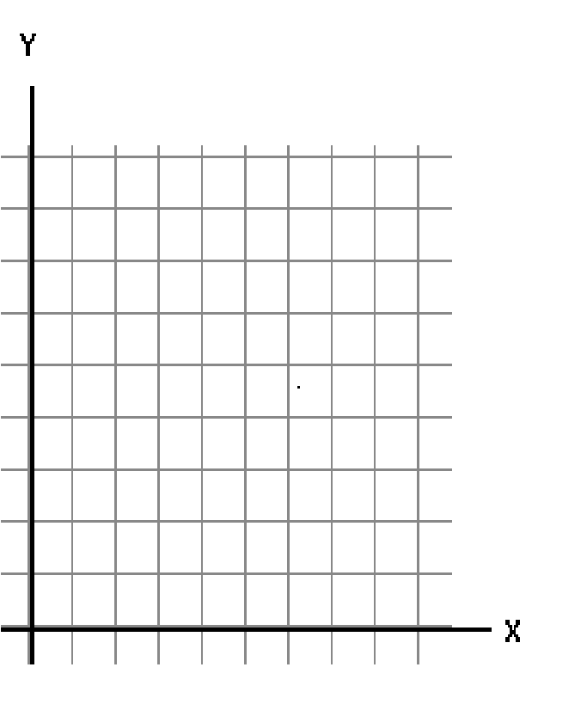

- Using your data table, what seems to be the trend as the % of light decreases? WHY?

- Using your data table, what seems to be the trend as the % of light increases? WHY?

- Where would you say this organism is using as much energy as they are making? WHY?

- Using your table and graph, explain why most of the time there are bigger plants on land than in the sea? Explain this in terms of evolution.

- There are 300 falcons living in a certain forest at the beginning of 2013. Suppose that every year there are 50 falcons born and 30 falcons that die.

- What is the population growth rate (include units)? Interpret the value.

- What is the per capita growth rate of the falcons over a year? Interpret the value.

Year | Population
2013
2014
2015
2016
2017
2018
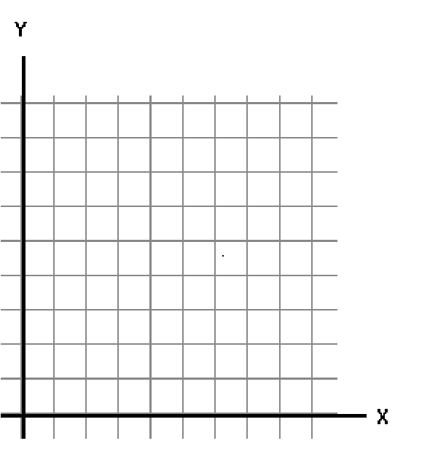
- Fill in the table and the construct a graph.

- Find the average rate of change for the falcon population from 2013 to 2018 (include units). Interpret the value.

- Kentwood, Michigan had a population of 49,000 in the year 2013. The infrastructure of the city allows for a carrying capacity of 60,000 people. r_{max} = .9 for Kentwood.

- Is the current population above or below the carrying capacity? Will the population increase or decrease in the next year?

- What will be the population growth rate for 2013 (include units)?

- What will be the population size at the start of 2014.

Year | Population size | Population growth rate
2013
2014
2015
2016
2017
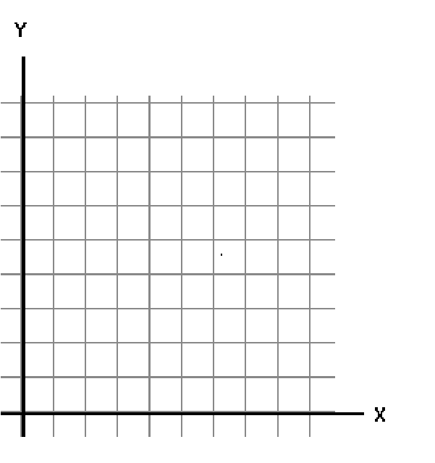
- Fill in the following table. Then graph year vs. population size.

- What happened to the population size over the years? What happened to the population growth rate over the years?

- Explain your answer from part (e) using what you know about carrying capacity.

- Explain your answer from part (e) using the formula: dN = r_{max}N ^{K − N} 
dt  K 

