AP BIOLOGY REVIEW – DAY 1
BIOCHEMISTRY/CELLS/VIRAL CYCLES
- How many covalent bonds can carbon form?........................................................................
- Hydrogen bonds form between .............................................................................................
- pH is a measure of .................................................................................................................
- What is a buffer?.....................................................................................................................
- Name the following functional groups:
    - -OH – ............................................................................................
    - C=O ............................................................................................
    - -COOH ............................................................................................
    - -NH₂ ............................................................................................
    - -SH ............................................................................................
    - -PO₄⁻ ............................................................................................
- What is the general formula for a monosaccharide?.............................................................
    - What is the function of monsaccharides?..................................................................
    - List three examples of monosaccharides ..................................................................
- What are polysaccharides?......................................................................................................
a. What are the functions of polysaccharides?.............................................................................................. b. What are the functions of
      - glycogen ...................................................................................................................................
      - starch ...................................................................................................................................
      - iii. cellulose ...................................................................................................................................
iv. chitin ...................................................................................................................................
- What are the structural components of fats, phospholipids, and steroids? ...............................................................
    - Fats store ............................................................................................................................................
    - Phospholipids form .............................................................................................................................
    - Steroids may function as ....................................................................................................................
- Proteins are polymers of ................................ joined by ............................................
    - Describe the following structures of proteins:
    - primary .......................................................................................................................................
    - secondary ...................................................................................................................................
    - tertiary .........................................................................................................................................
    - quaternary ...........................................................................................................................
- The three parts of a nucleotide are ..............................................................................
  - A and G are ..............................................; C and T are ................................
- List eight organelles found in the cell and their functions.
  - .............................
  - ..............................
  - ..............................
  - ..............................
  - ..............................
  - ..............................
  - ..............................
  - ..............................
- What type of cells do protists have? …………………………………………………………………………………..
- What are the differences between diffusion and active transport?
  - ..................................................................................................................................................
- Define hypotonic, hypertonic and isotonic.................................................................................................................................
- List some differences between viruses and bacteria.................................................................................................................
- What are the differences between the lytic and lysogenic cycle?
  - lytic.........................................................................................................................................
  - lysogenic................................................................................................................................
16. Joe has a 2 g/L solution. He dilutes it and creates 3 L of a 1 g/L solution. How much of the original solution did he dilute?
- Joe has 20 L of a 2 g/L solution. He diluted it, and created 3 L of a 1 g/L solution. How did he make such a solution?
- Joe has 20 L of a 2 g/L solution. To this solution he adds 30 L. What is the final concentration of the solution?
- Which is more acidic? (H⁺) of 1.0 x 10⁻⁸ or 1.0 x 10⁻¹²

- Which is more basic? (H⁺) of 1.0 x 10⁻⁶ or 1.0 x 10⁻³

Analyze the following cells (units not to scale), and determine the following…

Cell 1 (spherical) where the radius is 3 mm
Cell 2 (flat and rectangular) where the height is 0.5mm, length is 4mm, width is 2mm

- What is the surface area to volume ratio of both cells?

How to calculate Surface Area? | Surface area | How to calculate Volume? | Volume | Surface area to Volume Ratio
Cell 1
Cell 2

- Conclusion: Compare the ratios and explain why one cell would be more efficient than another.

- Water potential in potato cells was determined in the following manner. The initial masses of six groups of potato cores were measured. The potato cores were placed in sucrose solutions of various molarities. The masses of the cores were measured again after 24 hours. Percent changes in mass were calculated. The results are shown below.
Molarity of  Sucrose in  Beaker | Percent Change in Mass
0.0 M | 18.0
0.2 | 5.0
0.4 | -8.0
0.6 | -16.0
0.8 | -23.5
1.0 | -24.0
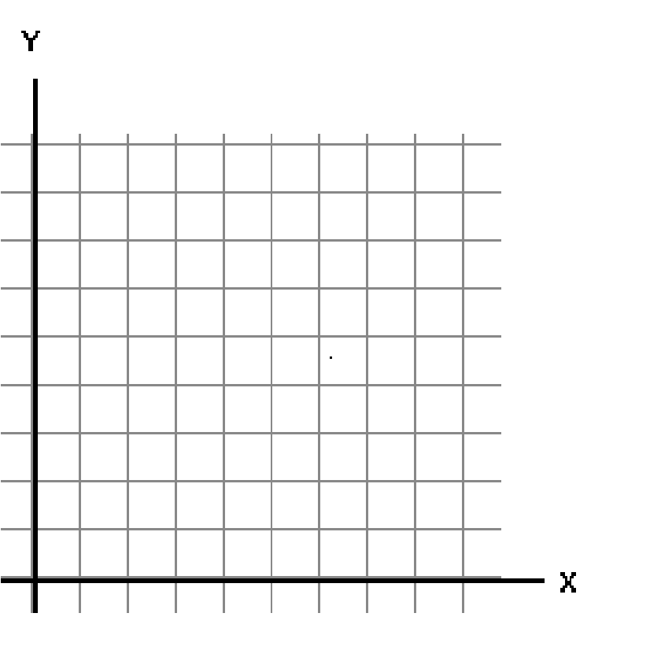

Graph these data. From your graph, label where the cells were hypotonic and the solution was hypertonic, and vice versa. Determine the apparent molar concentration (osmolarity) of the potato core cells.
- Pressure potential is always (positive/negative), while solute potential is always (positive/negative).
- When Solution potential goes down (gets more negative), water potential ____________________
- When Pressure potential goes down (gets smaller), water potential ____________________
- When would the pressure in a cell rise? (Under what conditions?)
- What would happen to the solute potential when Concentration is increased (justify with equation)? WHY?
- What would happen to the solute potential when the dissolved substance is glucose vs. salt (justify with equation)? WHY?
- Why is water potential important for plants? What are they lacking?
- Predict what would happen to animal cells placed in 0.0M and 1.0M concentration solutions.
- Draw and Label: a plant cell when placed in all three types of solutions. Include water potential
- Draw and Label: lytic cycle of virus

