AP Biology Plant Unit Study Guide
- Sketch a cladogram including the four major groups of land plants and include the major derived characters.

- Review your knowledge of the structure, life cycles, evolution and uses of the major land plant groups. Match each statement with a group or groups of plants.
A. Bryophytes (Mosses) | ________ 1. Flowering plants
B. Ferns | ________ 2. Two types of plants that produce seeds
C. Gymnosperms | ________ 3. The simplest vascular plants
D. Angiosperms | ________ 4. Plants that produce fruits
 | ________ 5. Nonvascular plants
 | ________ 6. Two types of plants with flagellated swimming sperm
 | ________ 7. Conifers
 | ________ 8. Roses, apples, maples, daisies
 | ________ 9. Two types of plants whose spores develop into pollen and ovules
 | ________ 10. The group that first developed good roots and rigid stems
 | ________ 11. The simplest plants
 | ________ 12. Plants that produce “naked” seeds
 | ________ 13. The majority of modern land plants
 | ________ 14. Two types of plants without seeds
 | ________ 15. Source of most of our food

- Which derived character enabled plants to move away from water?
- Which group(s) rely on water for fertilization?
- Which group(s) rely on pollination for fertilization?
- How do seedless vascular plants disperse?
- Identify the two types of vascular tissue and their functions.
- Review alternation of generations. Just get the big idea.
- Review the parts of the flower and their functions. Be prepared to label a diagram. For practice, match each flower part with its function.
- Petal | ________ 1. Eggs develop in this chamber.
- Style | ________ 2. Consists of filament and anther.
- Sepal | ________ 3. Produces pollen.
- Ovary | ________ 4. Attracts pollinators.
- Stamen | ________ 5. Female structure with ovary at its base.
- Carpel | ________ 6. Protects the flower before it opens.
- Stigma | ________ 7. Sticky tip that traps pollen.
- Filament | ________ 8. Stalk that supports anther
- Anther | ________ 9. Between stigma and ovary.

- Review the actions of the five classes of plant hormones by matching the hormones with their overall functions.
- Abscisic acid | ________ 1. Stimulate cell division and growth, affect root growth; oppose auxin by stimulating branching
- Cytokinins | ________ 2. Stimulates stem elongation; affects root growth, fruit development, tropisms
- Gibberellins | ________ 3. Inhibits growth, maintains dormancy, closes stomata during stress
- Ethylene | ________ 4. Promote seed germination and bud development, stem elongation, leaf growth, flower and fruit development
- Auxin | ________ 5. Promotes fruit ripening, leaf drop, aging; opposes some auxin effects

- Tropisms are directed growth responses that enable plants to adapt to environmental circumstances. Complete this chart comparing tropisms.
Name | Description | Mechanism
Phototropism

 | Growth movement in response to gravity
 |  | Contact triggers greater growth on opposite side, causing tendril to bend toward support

- Review leaf anatomy. What is the function of each labeled part? Name them.

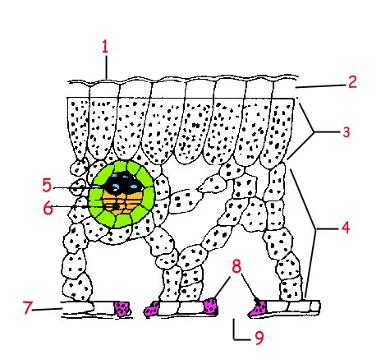

- Review angiosperm pollination. Complete the chart about methods of pollination.
Mechanism | Special adaptations
Wind
 | Light colored flowers with nice smell
 | Colorful flowers that smell sweet and produce nectar
Birds

- Complete the chart about angiosperm seed dispersal.
Mechanism |  | Description | Example
Water

Wind

Animal other than ingestion
Animal through ingestion

- Review transpiration. What is transpiration pull?

- What is needed for seeds to come out of dormancy? What is the first stage of seed germination? What hormone is involved?

- What are some adaptations of xerophytes?

- What are mycorrhizae? How does each part benefit each other? What type of relationship do they have?

- Complete the chart about plant groups
Group name | Description | Example
 | Plant grows on another plant, but does not obtain water and minerals from host plant
Parasitic plants

 |  | Venus Fly Trap
- How can plants deal with herbivory?

- Review water potential. Be prepared to solve some problems!

